# 

*Project for the Subject: Database System (COC-2070)*

# Project Title: ART GALLERY MANGEMENT SYSTEM

Discipline: BS Software Engineering

**Submitted By**:

**Aalyan Riasat (23-ntu-cs-1121)**

Section:

**SE-2ND-A**

**Submitted to:**

**Mr. Arsal Mehmood**

Submission date:

11-06-2024

**Department of Computer Science**

# Chapter One

**OBJECTIVE OF THE PROJECT**

**The main objective of creating an Art Gallery database project is**

* It is a website base project.
* To manage the details of gallery, exhibition, artwork and artist. It manages all the sales and inventory in the gallery. The purpose of the project is to build and application program to reduce the manual work.
* To tracks all the details about the sales of the artwork, the customer that bought it, etc. It manages the information about the artwork. Provides an information and description of the artworks left, thereby increasing the efficiency of managing the gallery. The organisation can maintain a computerized record of the artwork present in the gallery.
* To helps in the utilization of the resources in an effective manner. It maintains a list of all the customers and the various artwork that they have bought and the money that have invested in each.
* To maintains the record of exhibitions and various sales made during it. The objective of developing such computerized system is to reduce the paper work and safe of time in art gallery database management, thereby increasing the efficiency and decreasing the work load.

To develop such computerized system is to reduce the paper work and safe of time in art gallery database management, thereby increasing the efficiency and decreasing the work load.

## List of Final Entities

1. Gallery
2. Exhibition
3. Customer
4. Artwork
5. Artist
6. Contacts

## List of Final Relationships

* Artist **exhibits** Exhibition
* Exhibition explores Artwork
* Gallery contains Customers
* Gallery displays Artwork
* Customer **buys** Artwork
* Gallery conducts Exhibition

# Chapter Two

**ERD & Diagrams**

**ERD:**

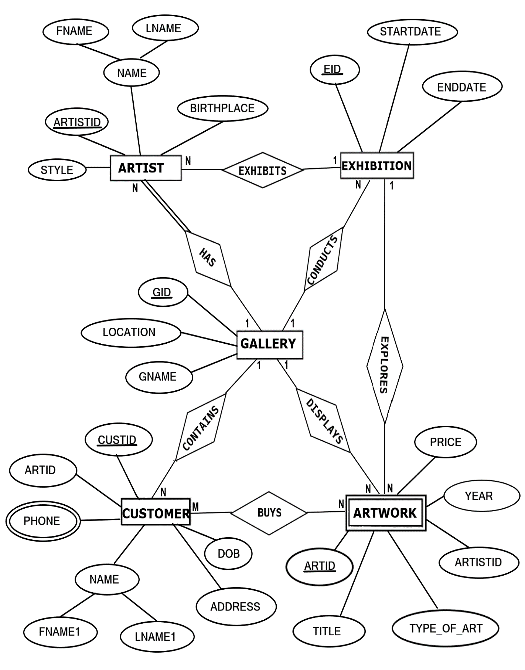

Figure : Erd Diagram

## Tables Converted from ERD

1. **Mapping of Regular Entities**

### 

**GALLERY**

|  |  |  |
| --- | --- | --- |
| **GID** | GNAME | LOCATION |

**EXHIBITION**

|  |  |  |
| --- | --- | --- |
| **EID** | STARTDATE | ENDDATE |

**ARTIST**

|  |  |  |  |  |
| --- | --- | --- | --- | --- |
| **ARTISTID** | FNAME | LNAME | BIRTHPLACE | STYLE |

**CUSTOMER**

|  |  |  |  |  |  |  |
| --- | --- | --- | --- | --- | --- | --- |
| **CUSTID** | **ARTID** | FNAME1 | LNAME1 | ADDRESS | PHONE | DOB |

**FK**

1. **Mapping of Weak Entity Types**

**ARTWORK**

|  |  |  |  |  |  |
| --- | --- | --- | --- | --- | --- |
| **ARTID** | **ARTISTID** | TITLE | TYPE_OF_ART | YEAR | PRICE |

1. **Mapping of 1:N Relationship**

**EXHIBITION**

|  |  |  |  |
| --- | --- | --- | --- |
| **EID** | STARTDATE | ENDDATE | **GID** |

**FK**

**ARTIST**

|  |  |  |  |  |  |  |  |
| --- | --- | --- | --- | --- | --- | --- | --- |
| **ARTISTID** | FNAME | LNAME | BIRTHPLACE | STYLE | **EID** | **GID** | **CUSTID** |

**FK FK FK**

**CUSTOMER**

|  |  |  |  |  |  |  |
| --- | --- | --- | --- | --- | --- | --- |
| **CUSTID** | **ARTID** | FNAME1 | LNAME1 | ADDRESS | DOB | **GID** |

**FK FK**

**ARTWORK**

|  |  |  |  |  |  |  |  |
| --- | --- | --- | --- | --- | --- | --- | --- |
| **ARTID** | **ARTISTID** | TITLE | TYPE_OF_ART | YEAR | PRICE | **EID** | **GID** |

**FK FK FK**

1. **Mapping of Multi-Valued Attributes**

**CONTACTS**

|  |  |
| --- | --- |
| **CUSTID** | PHONE |

**SCHEMA DIAGRAM**

**GALLERY**

|  |  |  |
| --- | --- | --- |
| **GID** | GNAME | LOCATION |

**EXHIBITION**

|  |  |  |  |
| --- | --- | --- | --- |
| **EID** | STARTDATE | ENDDATE | **GID** |

**CUSTOMER**

|  |  |  |  |  |  |  |
| --- | --- | --- | --- | --- | --- | --- |
| **CUSTID** | **ARTID** | FNAME1 | LNAME1 | ADDRESS | DOB | **GID** |

**ARTIST**

|  |  |  |  |  |  |  |  |
| --- | --- | --- | --- | --- | --- | --- | --- |
| **ARTISTID** | FNAME | LNAME | BIRTHPLACE | STYLE | **EID** | **GID** | **CUSTID** |

**ARTWORK**

|  |  |  |  |  |  |  |  |
| --- | --- | --- | --- | --- | --- | --- | --- |
| **ARTID** | **ARTISTID** | TITLE | TYPE_OF_ART | YEAR | PRICE | **EID** | **GID** |

**CONTACTS**

|  |  |
| --- | --- |
| **CUSTID** | PHONE |

# Chapter Three

## Normalization

**3 NORMALIZE THE RELATIONS**

Database normalization, or simply normalization, is the process of organizing the columns(attributes) and tables(relations) of a relational database to reduce data redundancy and improve data integrity. Normalization involves arranging attributes in relations based on dependencies between attributes.

1. **First Normal Form**

As per First normal form, no two rows of data must contain repeating group of information. Each set of columns must have a unique value, such that multiple columns cannot be used to fetch the same row. Each table should be organized into rows, and each row should have a primary key that will distinguishes it as unique.

**Example:**

**GALLERY**

|  |  |  |
| --- | --- | --- |
| **GID** | GNAME | LOCATION |

All the tables in the database are normalized to 1NF as all the attributes are atomic.

1. **Second Normal Form (2NF)**

A table is in 2NF if it is in 1NF and if all non-key attributes are fully functionally dependent on all of the key.

**Example:**

**CUSTOMER**

|  |  |  |  |  |  |  |
| --- | --- | --- | --- | --- | --- | --- |
| **CUSTID** | **ARTID** | FNAME1 | LNAME1 | ADDRESS | DOB | **GID** |

**FD1**

**FD1**

|  |  |  |  |
| --- | --- | --- | --- |
| **CUSTID** | FNAME1 | LNAME1 | DOB |

1. **Third Normal Form(3NF):**

A table is in 3NF if it is in 2NF and if it has no transitive dependency. X->Y, Y->Z, X>Z

According to CODD’s definition a relation schema R is in 3NF. It satisfies 2NF and no non-prime attribute of R is transitively dependent on the primary key. All tables of database satisfies upto 3NF.

# Chapter four

## Forms and Forms Layout

* **Delete from gallery table**

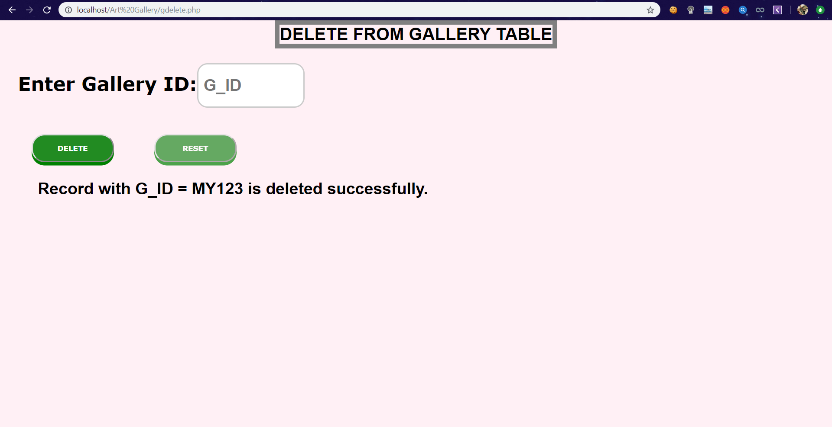

* **Insert in Gallery Table**

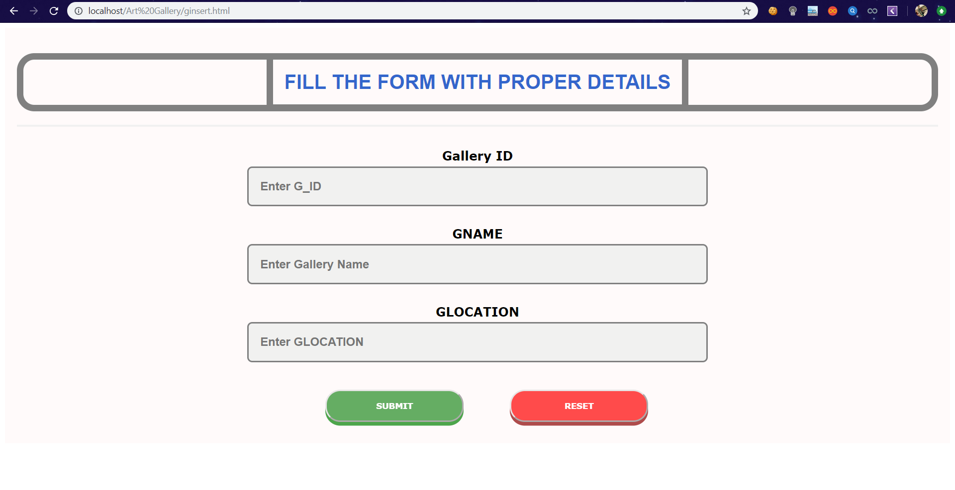

* **Search in Gallery Table**

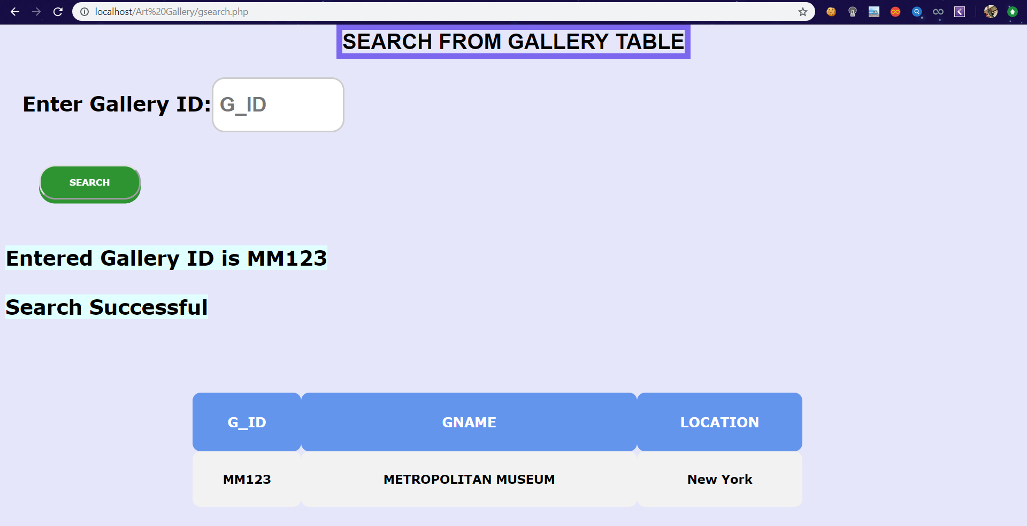

* **Front Page**

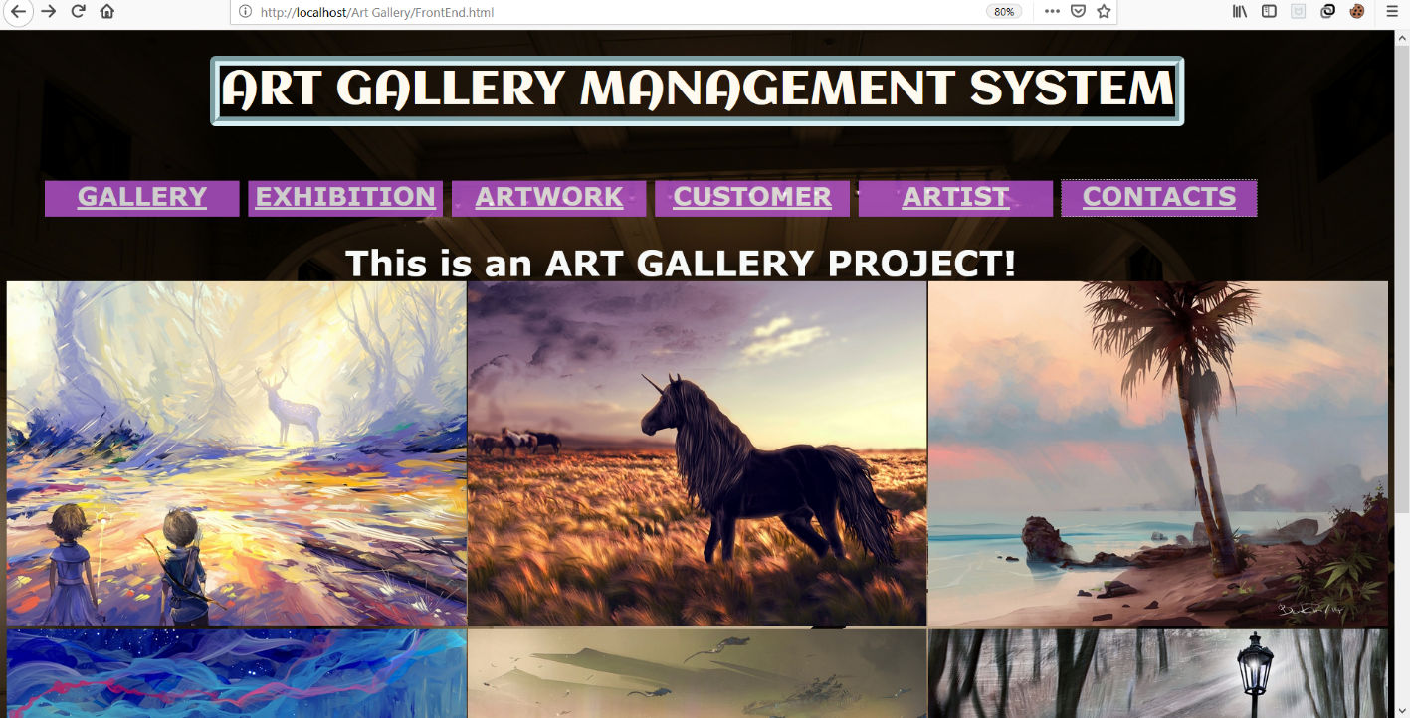

* **Customer**

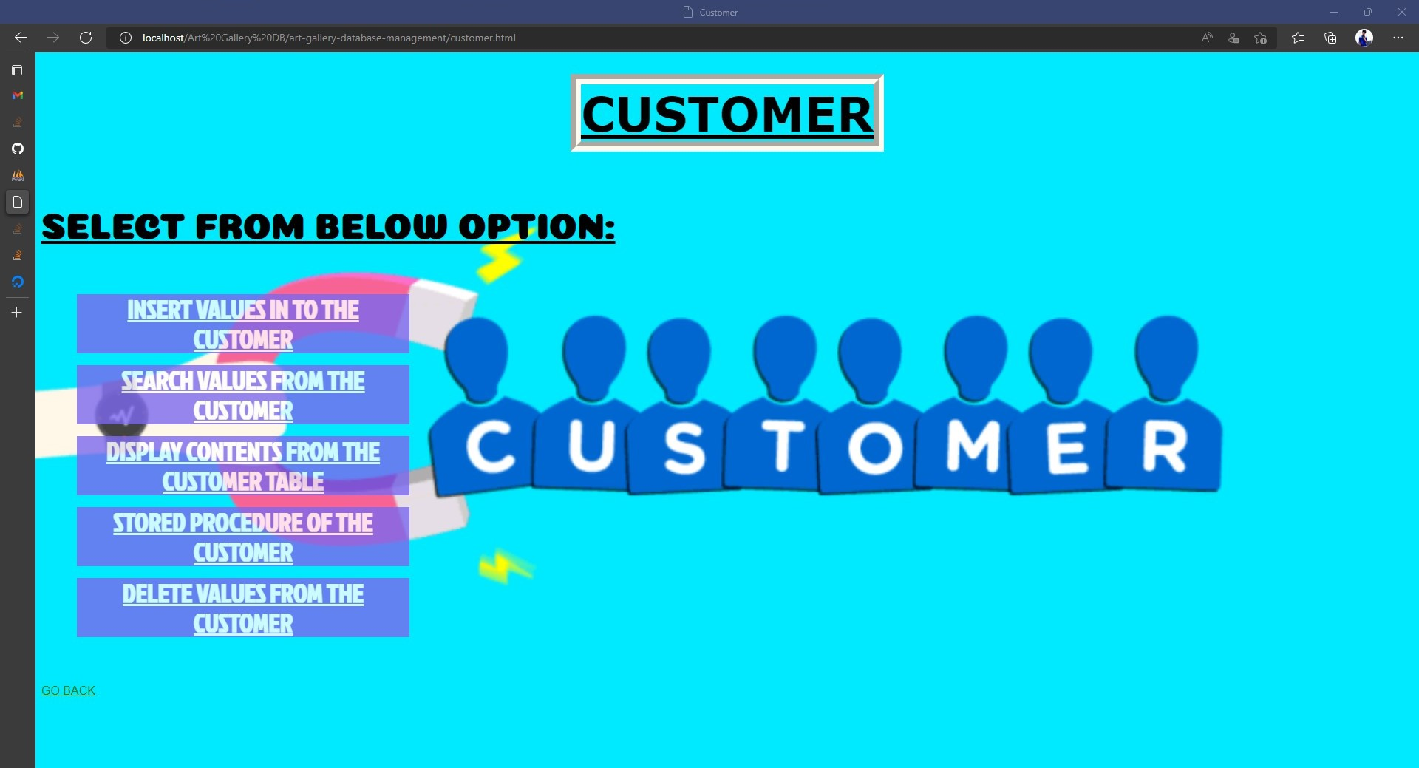

* **Artist**

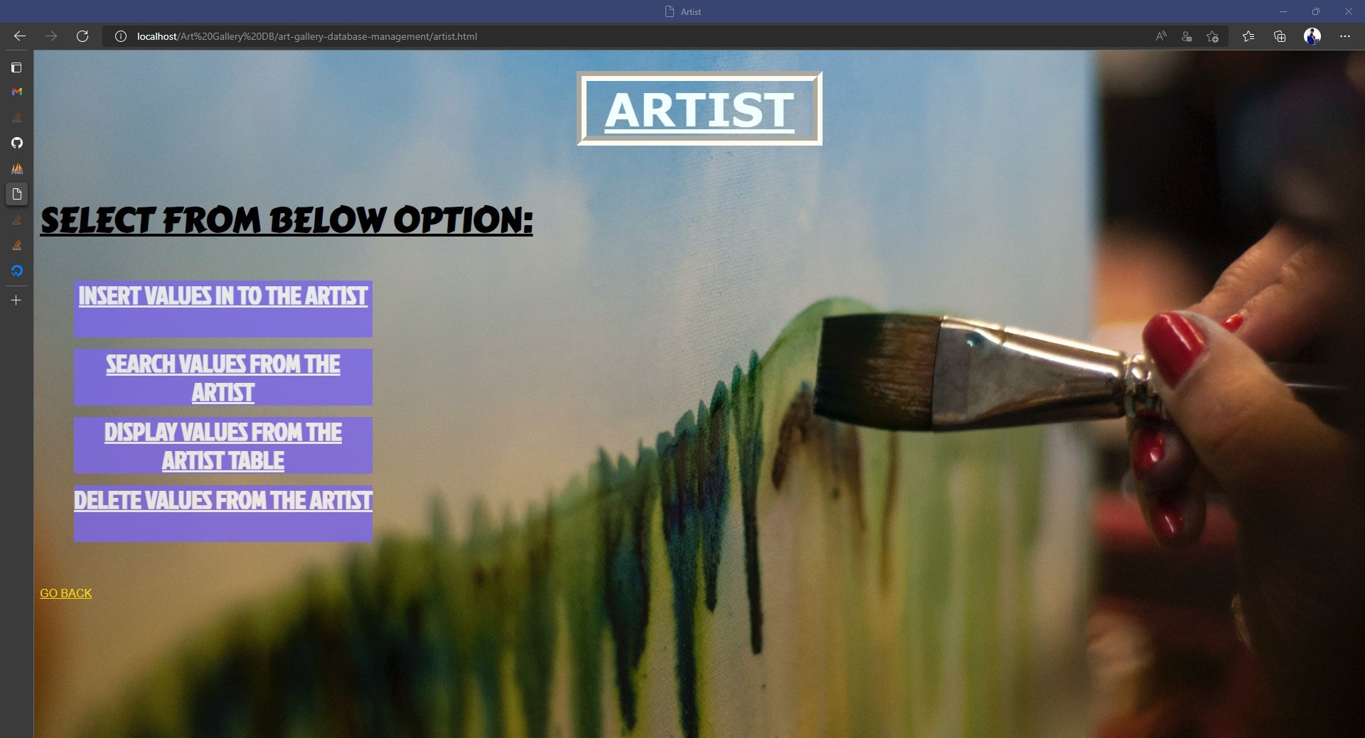

* **Contacts**

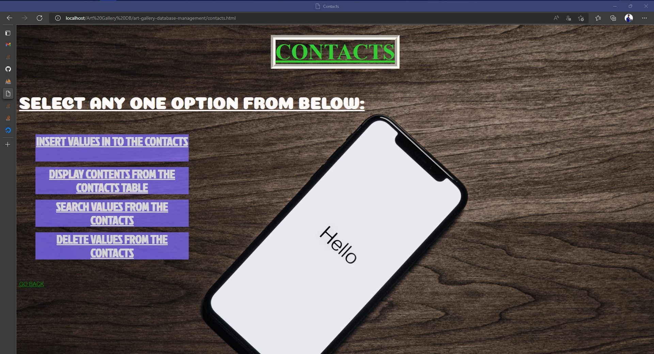

## Reports and Reports Layout

* Sales Report for Admin in Standard Layout.
* Purchases Report for Admin in Standard Layout.
* Seller’s Report for Admin in Standard Layout.
* Customer’s Report for Admin in Standard Layout.

# Chapter Five

**Final Classes of the Project:**

* Gallery
* Exhibition
* Contacts
* Customers
* Artist
* Artwork
* Contacts

**Languages I Used:**

* **HTML**
* **CSS**
* **BOOTSRATP**
* **JAVASCRIPT**
* **PHP**
* **SQL SERVER(PHP MY ADMIN)**